Guilds, Seals and Mottos:
Face Guilds:
Whaling Guild:
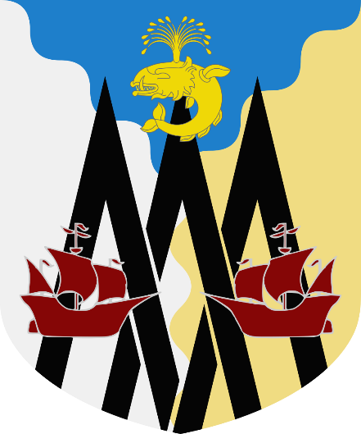
“Bonus Tempus Quod un Cete”
“A Whale of a Good Time”
Per pall wavy: azure, buff, and argent. Three chevronels interlaced sable. In middle chief, a whale embowed spouting or. In third quarter, a caravel reversed sanguine. In fourth quarter, a caravel sanguine.

Black Kettle Club:
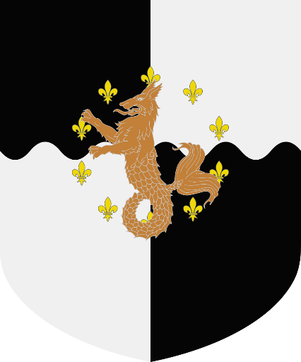
“Omnis Homo et Pisces”
“Every Man and his Fish”
Quarterly per fess-wavy: sable and argent. In fess point, ten fleur de lys in annulo or. In fess point, a sea wolf bronze.

The Ferrymen:
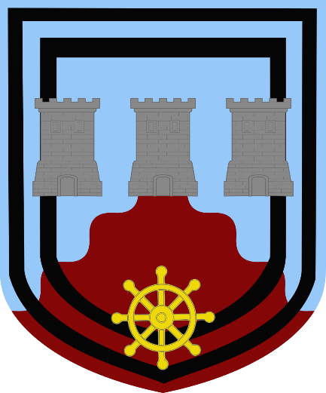
“Sanguis in Manibus”
“We Have Blood on our Hands”
Per chevron wavy: celestial-azure and sanguine. A double tressure sable. In middle base, a ships wheel or. Three towers in fess grey.

The Guild of Kinectricians:
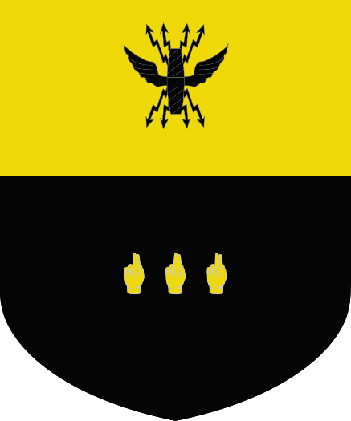
“Adipem Fulgur”
“Greased Lightning”
Per fess: or and sable. In middle chief, a thunderbolt sable. In nombril, three Hands of Benediction in fess or.

The Guards’ Guild:
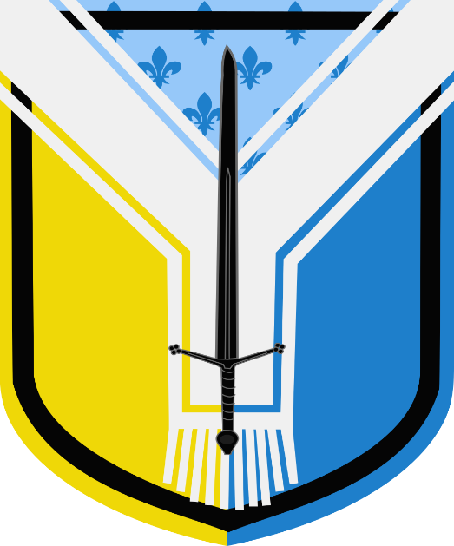
“Scelus, ei Ventura”
“Crime Happens”
Per pall: semy de lys - celestial-azure and azure - azure, and or. A tressure sable. A pallium argent. A claymore sable.

Guild of the Medics, Apiarists and Sericulturists:
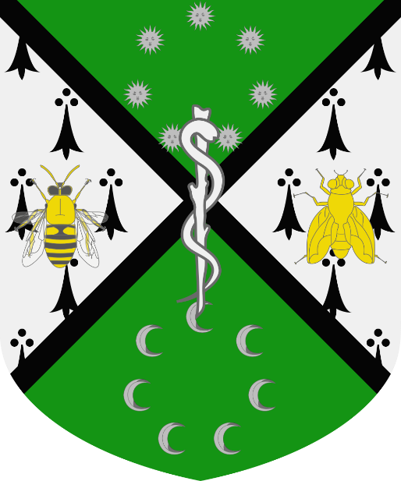
“Nos Faciemus in Musca”
“We do it on the Fly”
Per saltire: vert and ermine. A fillet saltire sable. In middle chief, seven Suns in Their Splendour in annulo steel. In middle base, seven moons decrescent in annulo steel. In dexter flank, a bee or. In sinister flank, a fly or. In fess point, a Rod of Asclepius argent.

Vichyssoimelliers’ Guild:
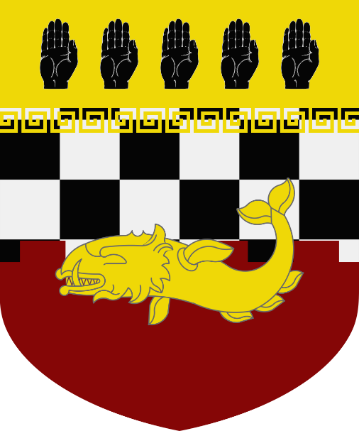
“Auget Calorem Faciemus”
“We Turn Up the Heat”
Per fess: embattled checky - sable and argent - and sanguine. On a chief meandering or, five hands sable. A whale or.

Backalley Guilds:
The Decent Regency and Aristocracy Guild:
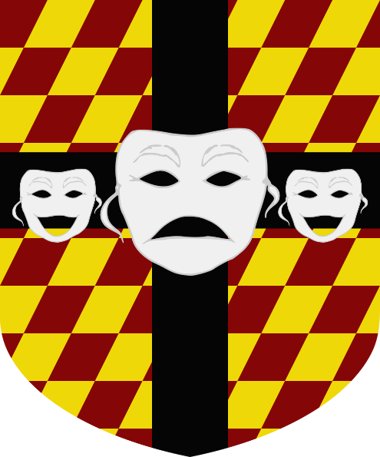
“Tres Est Turba”
“Three’s a Crowd”
Barry bendy sinister: sanguine and or. A plain cross sable. In dexter flank, a comedy mask argent. In sinister flank, a comedy mask argent. In fess point, a tragedy mask argent.

The Premonitory Press:
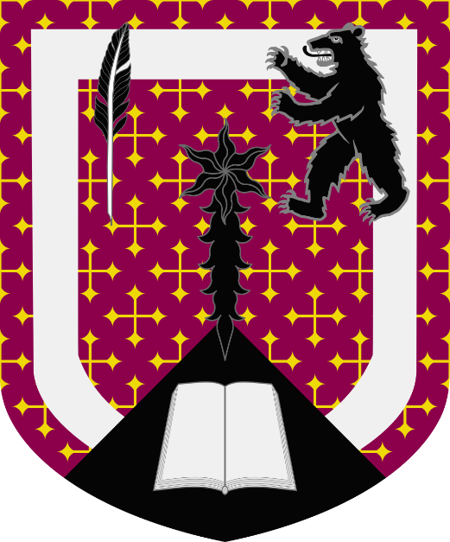
“In Ursus Malum Nuntium”
“The Bear of Bad News”
Crusilly: murrey and or. An orle argent. A point in point sable. In first quarter, a quill pen sable. In second quarter, a bear rampant sable. In middle base, a newspaper open argent. In fess point, a comet sable.

The Piracy Guild:
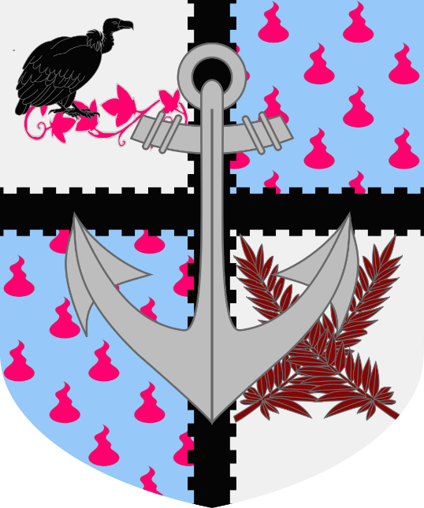
“Quia Occasiones, hoc Requirere Fures”
“Opportunities Take a Thief”
Quarterly: argent and goutty - celestial-azure and rose. A fillet cross embattled brettessy sable. In first quarter, an ivy vine rose. In dexter chief, a vulture reversed sable. In fourth quarter, 2 palm leaves in saltire sanguine. An anchor steel.

The Guild of Noses:
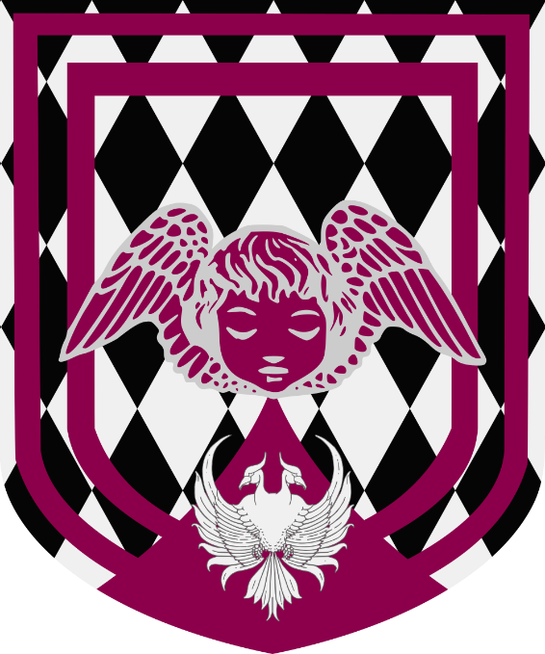
“Sub Nasum Tuum”
“Under Your Nose”
Lozengy: sable and argent. A double tressure murrey. An enty in point murrey. In middle base, a phoenix double headed argent. A cherub murrey.

